МГТУ им. Н.Э. Баумана

**Дисциплина Архитектура ЭВМ**

**Лабораторный практикум №4**

**теме: «Исследование синхронных счетчиков»**

**Вариант №4**

Работу выполнил:

студент группы ИУ7-46Б

Гасанзаде М.А.

Москва 2019 г.

**Цель работы**: изучение принципов построения счетчиков, овладение методом синтеза синхронных счетчиков, экспериментальная оценка динамических параметров счетчиков, изучение способов наращивания разрядности синхронных счетчиков.

**Задание №1**

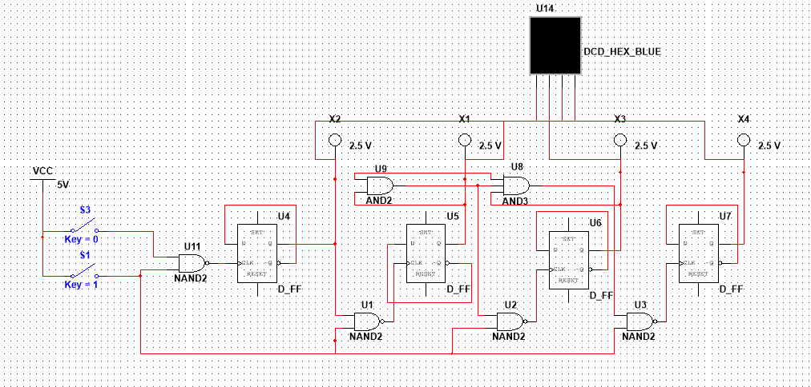

**Задание №2**

Вариант 0,1,2,3,4,5,8,9,10,11

Таблица значений функции возбуждения триггера:

|  |  |  |  |  |  |  |  |  |  |  |  |  |  |  |  |
| --- | --- | --- | --- | --- | --- | --- | --- | --- | --- | --- | --- | --- | --- | --- | --- |
| Q3 | Q2 | Q1 | Q0 | Q3* | Q2* | Q1* | Q0* | J3 | K3 | J2 | K2 | J1 | K1 | J0 | K0 |
| 0 | 0 | 0 | 0 | 0 | 0 | 0 | 1 | 0 | A | 0 | A | 0 | A | 1 | A |
| 0 | 0 | 0 | 1 | 0 | 0 | 1 | 0 | 0 | A | 0 | A | 1 | A | A | 1 |
| 0 | 0 | 1 | 0 | 0 | 0 | 1 | 1 | 0 | A | 0 | A | A | 0 | 1 | A |
| 0 | 0 | 1 | 1 | 0 | 1 | 0 | 0 | 0 | A | 1 | A | A | 1 | A | 1 |
| 0 | 1 | 0 | 0 | 0 | 1 | 0 | 1 | 0 | A | A | 0 | 0 | A | 1 | A |
| 0 | 1 | 0 | 1 | 1 | 0 | 0 | 0 | 1 | A | A | 1 | 0 | A | A | 1 |
| 1 | 0 | 0 | 0 | 1 | 0 | 0 | 1 | A | 0 | 0 | A | 0 | A | 1 | A |
| 1 | 0 | 0 | 1 | 1 | 0 | 1 | 0 | A | 0 | 0 | A | 1 | A | A | 1 |
| 1 | 0 | 1 | 0 | 1 | 0 | 1 | 1 | A | 0 | 0 | A | A | 0 | 1 | A |
| 1 | 0 | 1 | 1 | 0 | 0 | 0 | 0 | A | 1 | 0 | A | A | 1 | A | 1 |

Карты Карно:

|  |  |  |  |  |
| --- | --- | --- | --- | --- |
| Q3 Q2 (J3)  Q1 Q0 | 00 | 01 | 11 | 10 |
| 00 | 0 | 0 | - | A |
| 01 | 0 | 1 | - | A |
| 11 | 0 | - | - | A |
| 10 | 0 | - | - | A |

|  |  |  |  |  |
| --- | --- | --- | --- | --- |
| Q3 Q2 (K3)  Q1 Q0 | 00 | 01 | 11 | 10 |
| 00 | A | A | - | 0 |
| 01 | A | A | - | 0 |
| 11 | A | - | - | 1 |
| 10 | A | - | - | 0 |

|  |  |  |  |  |
| --- | --- | --- | --- | --- |
| Q3 Q2 (J2)  Q1 Q0 | 00 | 01 | 11 | 10 |
| 00 | 0 | A | - | 0 |
| 01 | 0 | A | - | 0 |
| 11 | 1 | - | - | 0 |
| 10 | 0 | - | - | 0 |

|  |  |  |  |  |
| --- | --- | --- | --- | --- |
| Q3 Q2 (K2)  Q1 Q0 | 00 | 01 | 11 | 10 |
| 00 | A | 0 | - | A |
| 01 | A | 1 | - | A |
| 11 | A | - | - | A |
| 10 | A | - | - | A |

|  |  |  |  |  |
| --- | --- | --- | --- | --- |
| Q3 Q2 (J1)  Q1 Q0 | 00 | 01 | 11 | 10 |
| 00 | 0 | 0 | - | 0 |
| 01 | 1 | 0 | - | 1 |
| 11 | A | - | - | A |
| 10 | A | - | - | A |

|  |  |  |  |  |
| --- | --- | --- | --- | --- |
| Q3 Q2 (K1)  Q1 Q0 | 00 | 01 | 11 | 10 |
| 00 | A | A | - | A |
| 01 | A | A | - | A |
| 11 | 1 | - | - | 1 |
| 10 | 0 | - | - | 0 |

|  |  |  |  |  |
| --- | --- | --- | --- | --- |
| Q3 Q2 (J0)  Q1 Q0 | 00 | 01 | 11 | 10 |
| 00 | 1 | 1 | - | 1 |
| 01 | A | A | - | A |
| 11 | A | - | - | A |
| 10 | 1 | - | - | 1 |

|  |  |  |  |  |
| --- | --- | --- | --- | --- |
| Q3 Q2 (K0)  Q1 Q0 | 00 | 01 | 11 | 10 |
| 00 | A | A | - | A |
| 01 | 1 | 1 | - | 1 |
| 11 | 1 | - | - | 1 |
| 10 | A | - | - | A |

**J3 = Q0*Q2**

**K3 = Q0*Q1**

**J2 = Q0*Q1*!Q3**

**K2 = Q0**

**J1 = (Q0*!Q2*!Q3)+(Q0*Q3)**

**K1 = Q0**

**J0 = 1**

**K0 = 1**

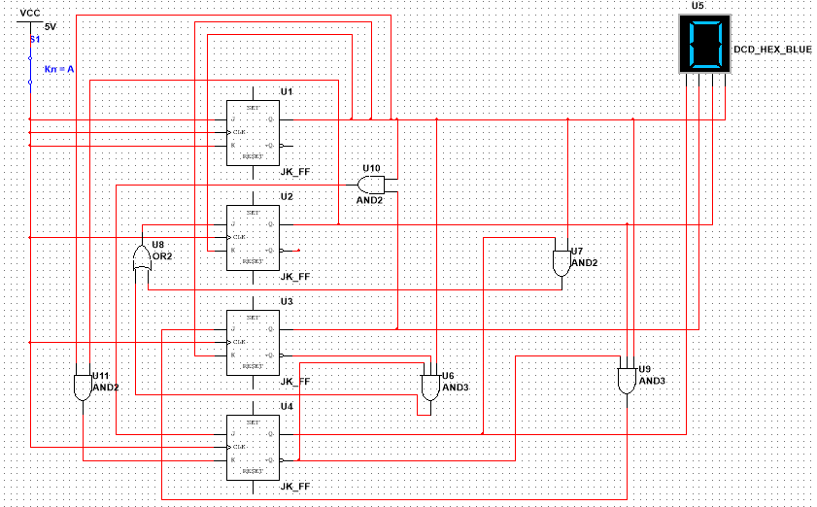

**Задание №3**

Счетчик 0-10

Таблица значений функции возбуждения триггера:

|  |  |  |  |  |  |  |  |  |  |  |  |  |  |  |  |
| --- | --- | --- | --- | --- | --- | --- | --- | --- | --- | --- | --- | --- | --- | --- | --- |
| Q3 | Q2 | Q1 | Q0 | Q3* | Q2* | Q1* | Q0* | J3 | K3 | J2 | K2 | J1 | K1 | J0 | K0 |
| 0 | 0 | 0 | 0 | 0 | 0 | 0 | 1 | 0 | A | 0 | A | 0 | A | 1 | A |
| 0 | 0 | 0 | 1 | 0 | 0 | 1 | 0 | 0 | A | 0 | A | 1 | A | A | 1 |
| 0 | 0 | 1 | 0 | 0 | 0 | 1 | 1 | 0 | A | 0 | A | A | 0 | 1 | A |
| 0 | 0 | 1 | 1 | 0 | 1 | 0 | 0 | 0 | A | 1 | A | A | 1 | A | 1 |
| 0 | 1 | 0 | 0 | 0 | 1 | 0 | 1 | 0 | A | A | 0 | 0 | A | 1 | A |
| 0 | 1 | 0 | 1 | 0 | 1 | 1 | 0 | 0 | A | A | 0 | 1 | A | A | 1 |
| 0 | 1 | 1 | 0 | 0 | 1 | 1 | 1 | 0 | A | A | 0 | A | 0 | 1 | A |
| 0 | 1 | 1 | 1 | 1 | 0 | 0 | 0 | 1 | A | A | 1 | A | 1 | A | 1 |
| 1 | 0 | 0 | 0 | 1 | 0 | 0 | 1 | A | 0 | 0 | A | 0 | A | 1 | A |
| 1 | 0 | 0 | 1 | 1 | 0 | 1 | 0 | A | 0 | 0 | A | 1 | A | A | 1 |
| 1 | 0 | 1 | 0 | 0 | 0 | 0 | 0 | A | 1 | 0 | A | A | 1 | 0 | A |

Карты Карно:

|  |  |  |  |  |
| --- | --- | --- | --- | --- |
| Q3 Q2 (J3)  Q1 Q0 | 00 | 01 | 11 | 10 |
| 00 | 0 | 0 | - | A |
| 01 | 0 | 0 | - | A |
| 11 | 0 | 1 | - | - |
| 10 | 0 | 0 | - | A |

|  |  |  |  |  |
| --- | --- | --- | --- | --- |
| Q3 Q2 (K3)  Q1 Q0 | 00 | 01 | 11 | 10 |
| 00 | A | A | - | 0 |
| 01 | A | A | - | 0 |
| 11 | A | A | - | - |
| 10 | A | A | - | 1 |

|  |  |  |  |  |
| --- | --- | --- | --- | --- |
| Q3 Q2 (J2)  Q1 Q0 | 00 | 01 | 11 | 10 |
| 00 | 0 | A | - | 0 |
| 01 | 0 | A | - | 0 |
| 11 | 1 | A | - | - |
| 10 | 0 | A | - | 0 |

|  |  |  |  |  |
| --- | --- | --- | --- | --- |
| Q3 Q2 (K2)  Q1 Q0 | 00 | 01 | 11 | 10 |
| 00 | A | 0 | - | A |
| 01 | A | 0 | - | A |
| 11 | A | 1 | - | - |
| 10 | A | 0 | - | A |

|  |  |  |  |  |
| --- | --- | --- | --- | --- |
| Q3 Q2 (J1)  Q1 Q0 | 00 | 01 | 11 | 10 |
| 00 | 0 | 0 | - | 0 |
| 01 | 1 | 1 | - | 1 |
| 11 | A | A | - | - |
| 10 | A | A | - | A |

|  |  |  |  |  |
| --- | --- | --- | --- | --- |
| Q3 Q2 (K1)  Q1 Q0 | 00 | 01 | 11 | 10 |
| 00 | A | A | - | A |
| 01 | A | A | - | A |
| 11 | 1 | 1 | - | - |
| 10 | 0 | 0 | - | 1 |

|  |  |  |  |  |
| --- | --- | --- | --- | --- |
| Q3 Q2 (J0)  Q1 Q0 | 00 | 01 | 11 | 10 |
| 00 | 1 | 1 | - | 1 |
| 01 | A | A | - | A |
| 11 | A | A | - | - |
| 10 | 1 | 1 | - | 0 |

|  |  |  |  |  |
| --- | --- | --- | --- | --- |
| Q3 Q2 (K0)  Q1 Q0 | 00 | 01 | 11 | 10 |
| 00 | A | A | - | A |
| 01 | 1 | 1 | - | 1 |
| 11 | 1 | 1 | - | - |
| 10 | A | A | - | A |

**J3 = Q0*Q1*Q2**

**K3 = Q1**

**J2 = Q0*Q1**

**K2 = Q0*Q1**

**J1 = Q0**

**K1 = Q0+Q3**

**J0 = !Q1*!Q3**

**K0 = 1**

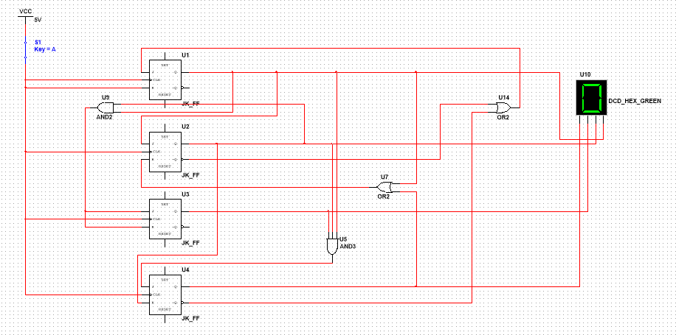

**Задание №4**

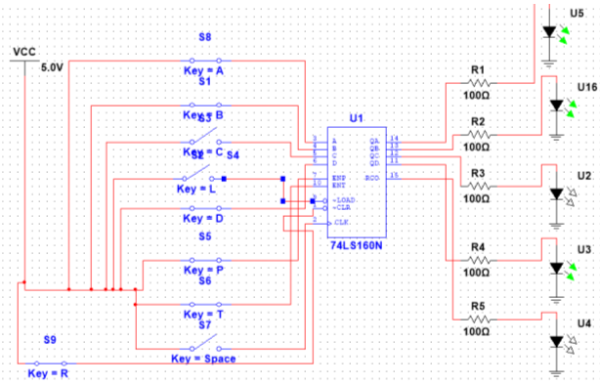

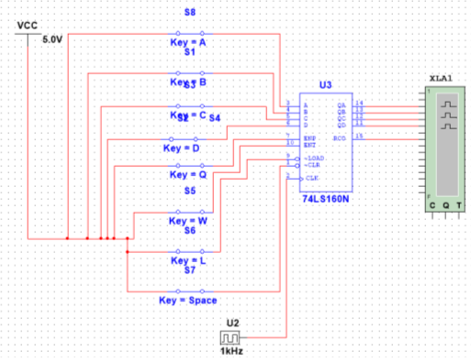

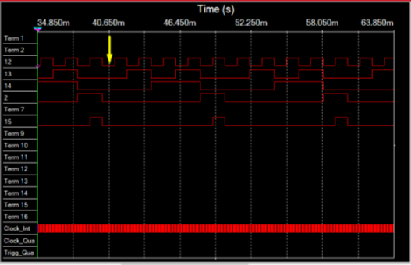

**Задание №5**

